# Erratic Step Identifier User Guide

Version: 1.0

Document Date: 18/11/2018

Author: Tansel Arif

## Introduction

The Erratic Step Identifier is an executable which can be used to identify steps in a trajectory that are erratic. The erraticity of a list of steps is defined as the number of value crossing events that have occurred where the value to be crossed is the average direction of the list of steps divided by the distance. For example a list of steps includes the distance and heading of a particular trajectory:

Steps = [(d_1,h_1),(d_2,h_2), … , (d_n,h_n)]

$$totalDistance= \sum_{i=1}^{n}{d_{i}}$$

$$averageDirection= \frac{\sum_{i=1}^{n}{h_{i}}}{n}$$

$$erraticity(Steps)=\frac{e}{totalDistance}$$

Where e is the number of times the signal [h_1, h_2, …, h_n] crosses averageDirection. This means that we have the following:

$$\lim_{totalDistance→∞}{erraticity→0}$$

And

$$e≫1 ⇨erraticity≫1$$

For constant totalDistance.

## Example Usage

### Simple Usage

Given a file of the following format (timestep, distance, heading,x,x):

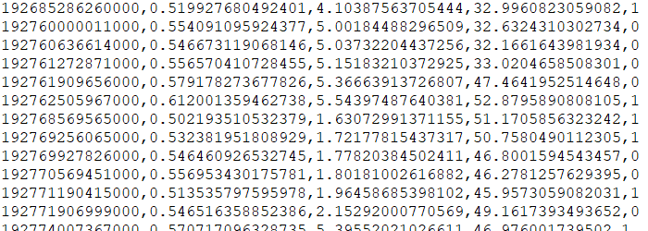

We can use ErraticStepIdentifier.exe in order to calculate the erraticity for each step using the command line as follows:

ErraticStepIdentifier.exe <Input File Path>

The output in the above example is a file in the same location as the input file path but with the ‘output’ string appended to the end of the path.

### Full usage

Given a file as specified above, the default behavior is calculate the erraticity of steps 1 – 5 then assign the resulting erraticity to step 1 then assign the erraticity of steps 2-6 to step 2 and so on. So given the original step log steps = [s_1, s_2, …, s_n], the erraticity of step s_i is calculated as

$$E\left(s_{i}\right)=erraticity(\left[s_{i},s_{i+1},…,s_{i+5}\right])$$

The ‘5’ above is called the size of the erraticity and is set to 5 by default. However, it is possible to provide this parameter as input as shown at the end of this section.

Additionally, it may not be practical to consider the headings 0.000001 and 0.0001 as different depending on the accuracy of the measuring equipment or the normal behavior of that which is being measured. In this case, it is possible to provide a ‘sensitivity’ parameter (which is not considered by default) to the call signature of the executable.

The full call to the executable is shown below:

ErraticStepIdentifier.exe <Input File Path> sensitivity size

Where sensitivity and size are integers. So that the call

ErraticStepIdentifier.exe <Input File Path> 0 5

Performs the erraticity calculations considering 5 steps at a time and a sensitivity of 0 decimal places which in this particular example may be a sound choice.

### Additional Examples

Additional examples for edge cases can be found in the *UnitTests.cpp* unit tests file accompanied with this package.

There are 5 files in the Debug folder of this package:

1. 2017-01-20Z14-30-05.steplog
2. 2017-01-20Z14-30-05.steplogoutput
3. resultsDefault.txt
4. resultsSensitivity_5_Size_3.txt
5. resultsSensitivity_5_Size_5.txt
6. resultsSensitivity_0_Size_5.txt

1 is an example input. 2 is an example output when only the input filename is specified (or when the input file is dragged onto the .exe file). 3 is an example output when the output filename is also specified. 4 is an example output when a sensitivity of 5 and a size of 3 is specified. 5 is an example output when a sensitivity of 5 and size 5 is specified. 6 is an example output when a sensitivity of 0 and a size of 5 is specified.

Notice that the smaller the sensitivity, the smaller the number of steps which are considered erratic.